The first and foremost characteristic of anyone is consciousness.

No one will tell you that this is the foundational Christian belief, but it is. The premise of God being conscious and intentional flows into everything being connected and intertwined. Given intentional choices, the result follows and is influenced/related in some for to the creator.

In the same way, a person is in some form related/connected/intertwined with all things that they consciously choose. Before I get carried away with philosophy and start discussing unity and spheres, let's move to the real topic and check out different personality proxies (aka: choices) that I have fun learning about to understand people with low resolution (aka: poor accuracy) but much fun and profit.

# **Technology**

People who use technology often make conscious choices over their technology. Whether it's smart watches, a specific phone, specific car features, or even specific application workflows there are some fun correlations.

The most popular groupings might be PC vs Console, Mac vs Windows, Arch Linux vs X, iPhone vs Android, etc.

Here's a picture of my keyboard, computer, and old keyboard:

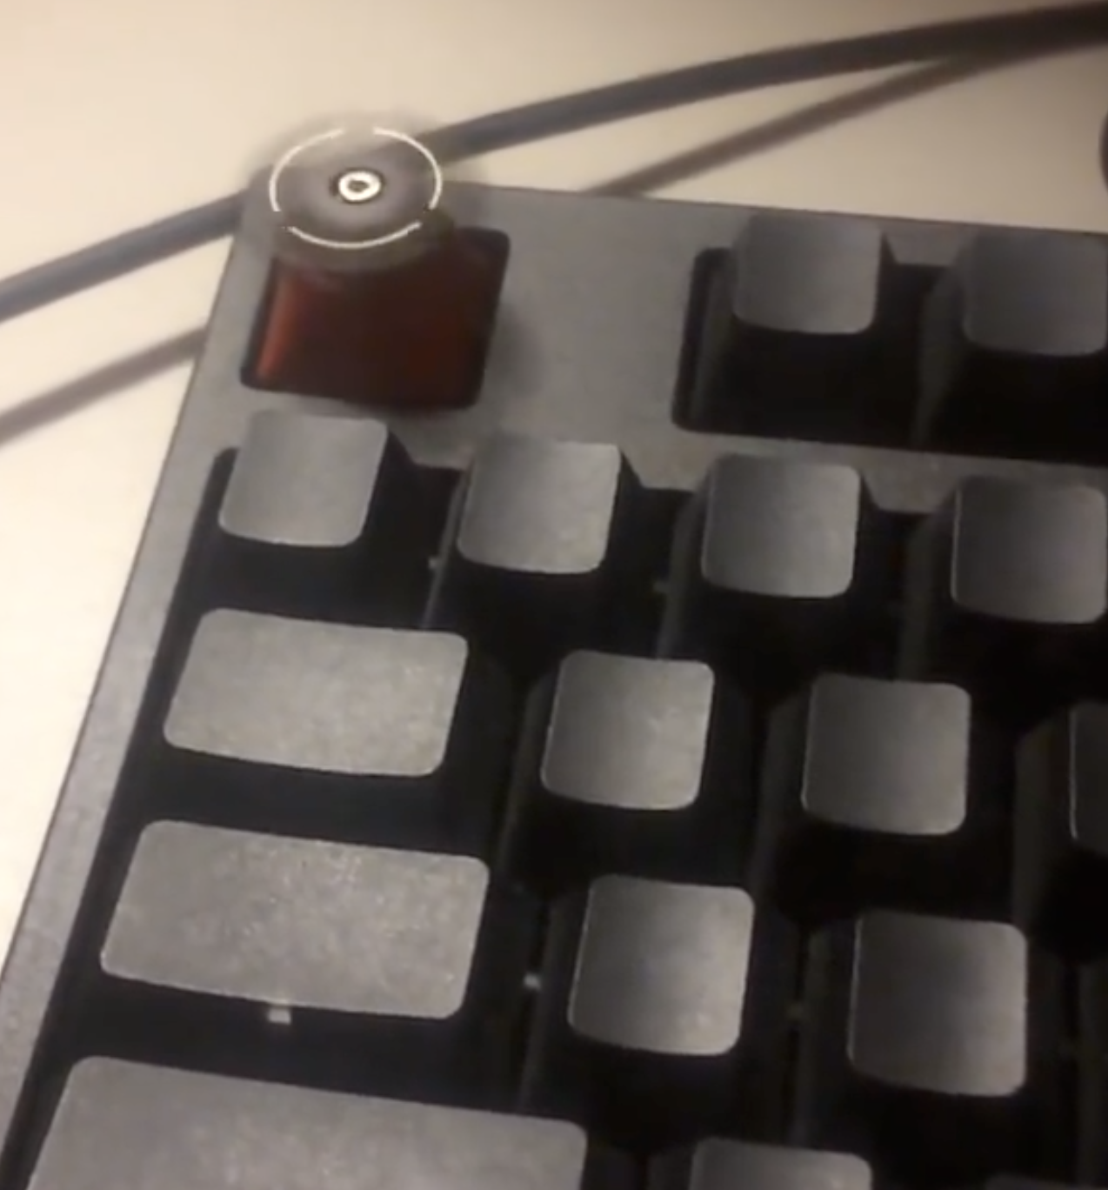

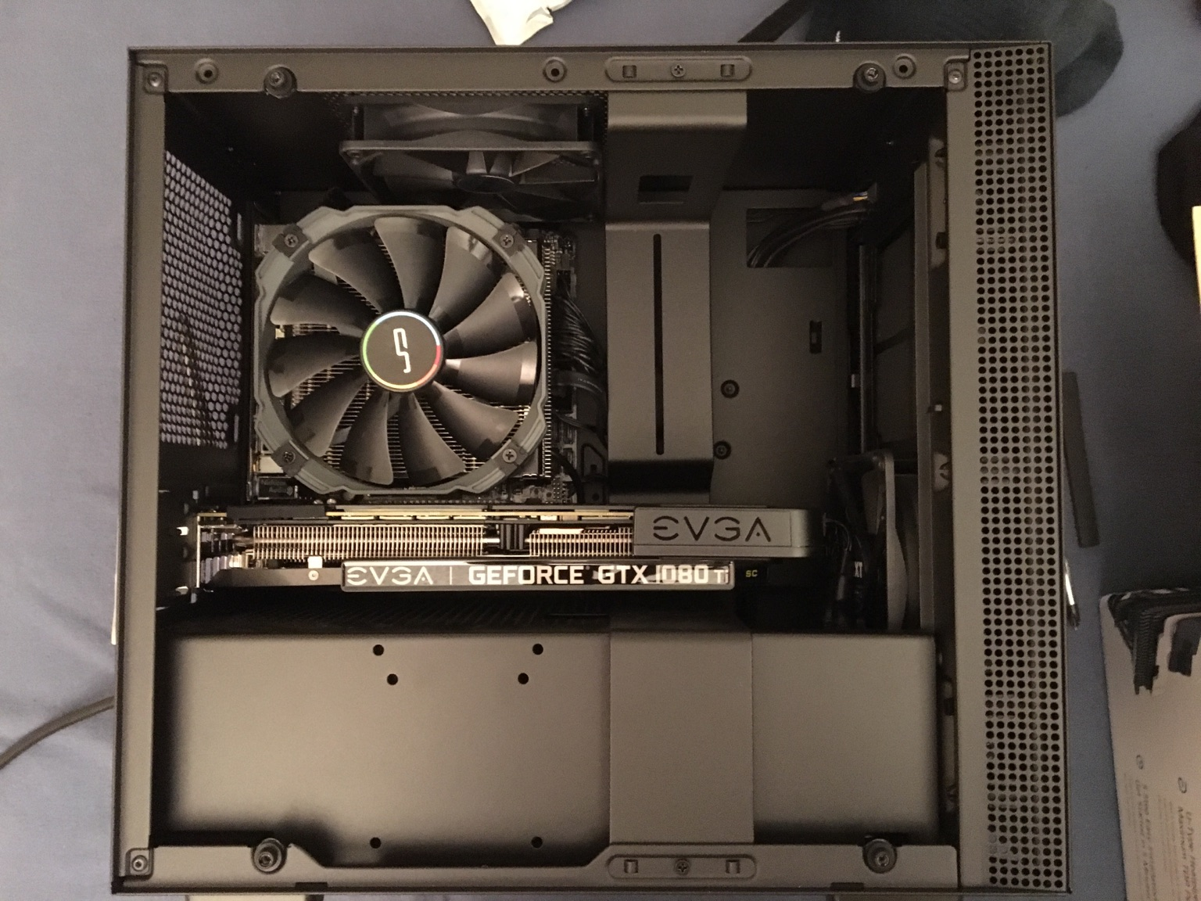

Another proxy can also be how we use our technology. There are correlations for what applications we use and how we use our phones and PCs. There are also correlations for the frequency, duration, and methodology.

My more recent favorite is drawing a correlation between how one structures their room (physical) and how clean it is and disciplined they are with it and the drawing of the correlation to how they structure their Desktop, Email Inbox, Browser Tabs, etc.



I'm reasonably confident the person who has a clean email inbox and a clean browser tabs and a clean desktop, is somewhat disciplined and values/puts effort into cleaning up their physical space as well.

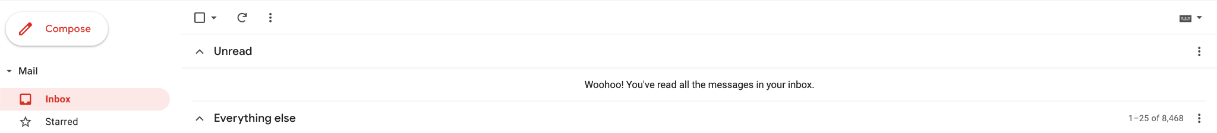

# **Fashion**

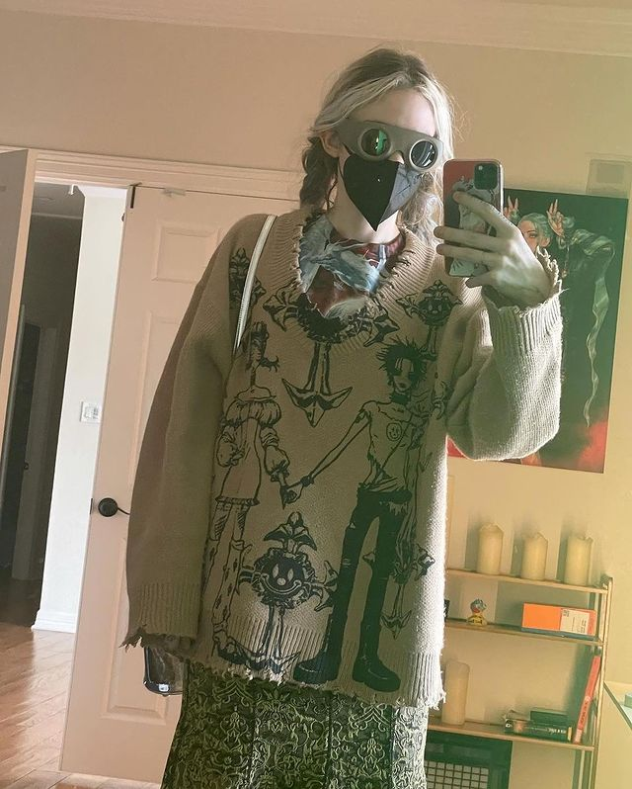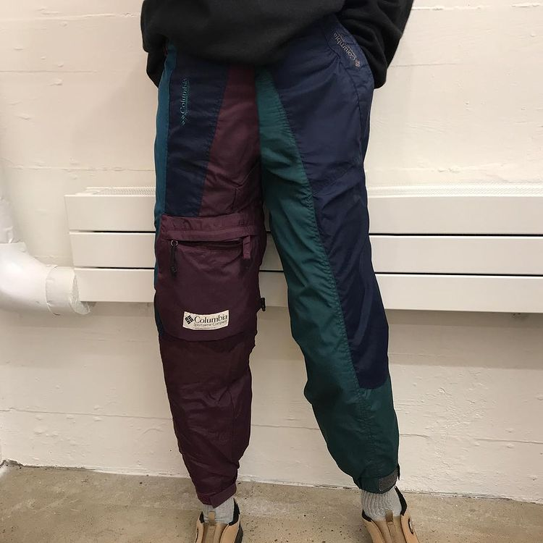

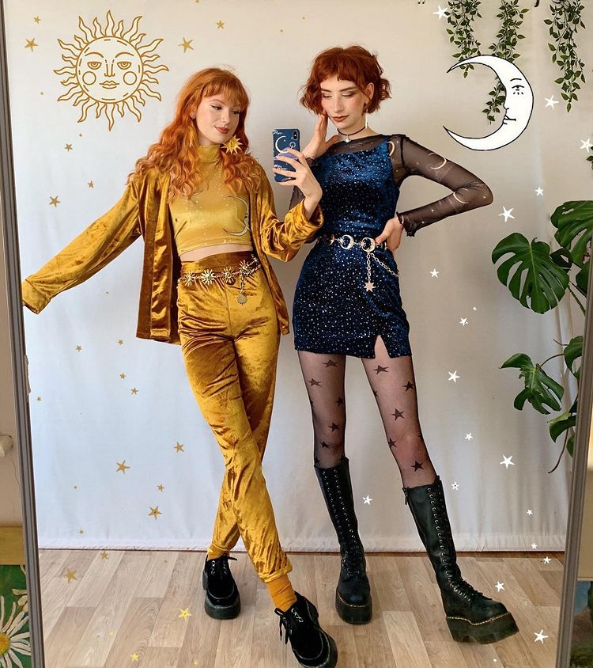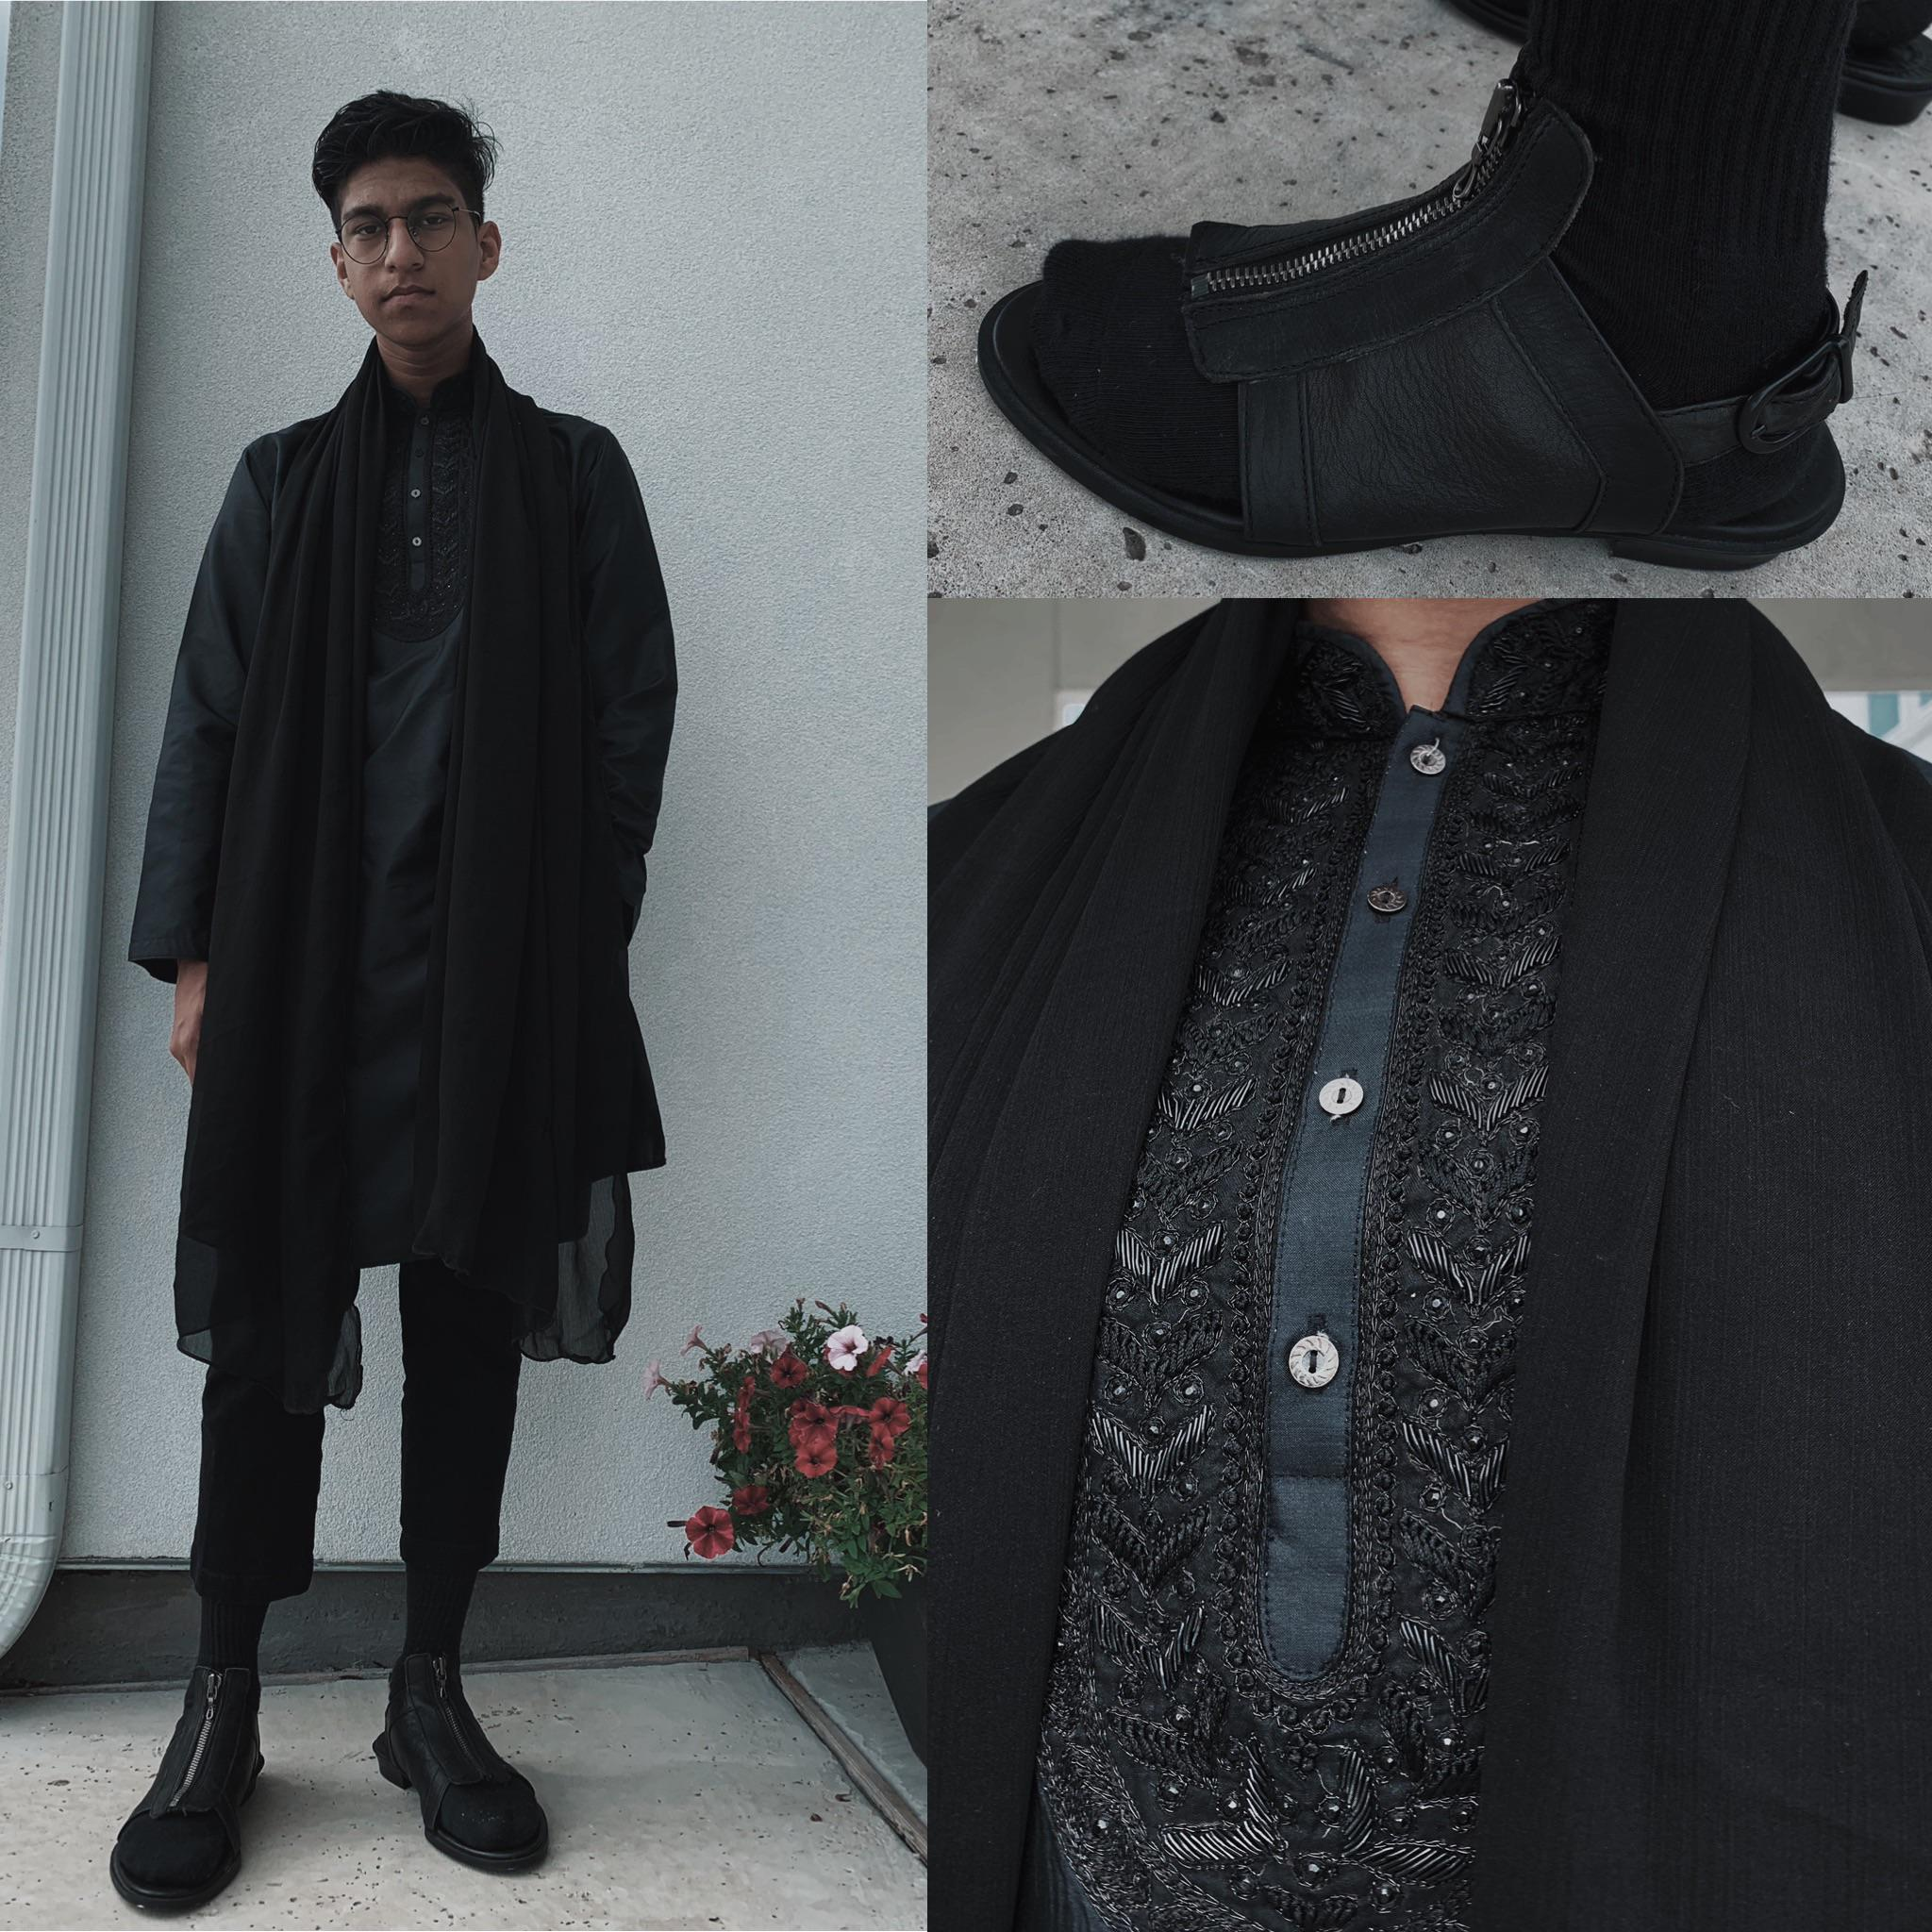

Above are some pictures that I think are great, though I'm not quite sure if I'd personally wear some of them. Regardless, fashion is an incredibly common indicator of personality. People care and put a ton of effort into how they look.

In terms of specifics, shoes are often the most intentional and more critical part of the outfit for a personality proxy. Shoes are often more expensive and a daily choice than a given shirt or pants.

Perhaps the only arguable fashion parallel to shoes might be accessories – tattoos, rings, necklaces, earrings, piercings, hair, etc.

# **Music**

Music is something I actually care about and deeply enjoy. I'm reasonably well-versed in music knowledge, especially in more indie artists and less-so with top-40.

The more knowledge of a section the more confidence I have at drawing correlations and using language to describe taste. That said, music is incredibly broad and most people are fans of multiple styles of music. Though often their favorite artist/style resembles a consistent BPM, aesthetic, or theme. Given my knowledge of music artists this is one of the higher confidence personality proxies; are you drawn to upbeat or calming? male or female artists? how experimental are your music tastes?

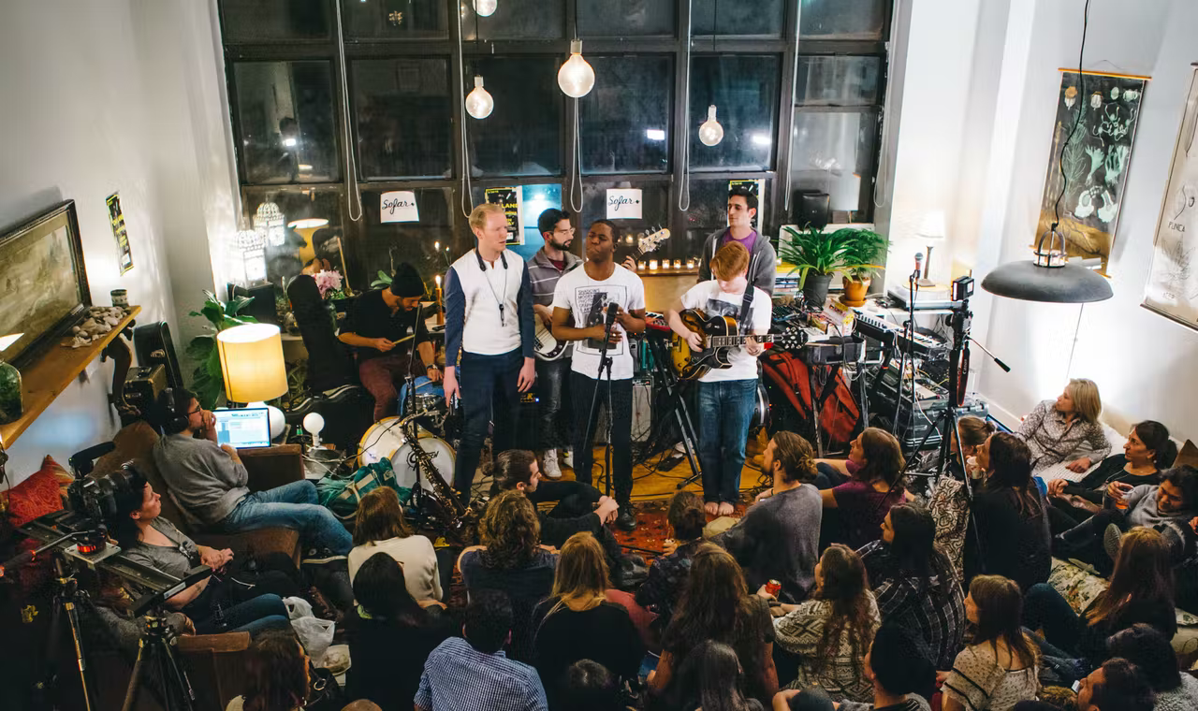

# **Art**

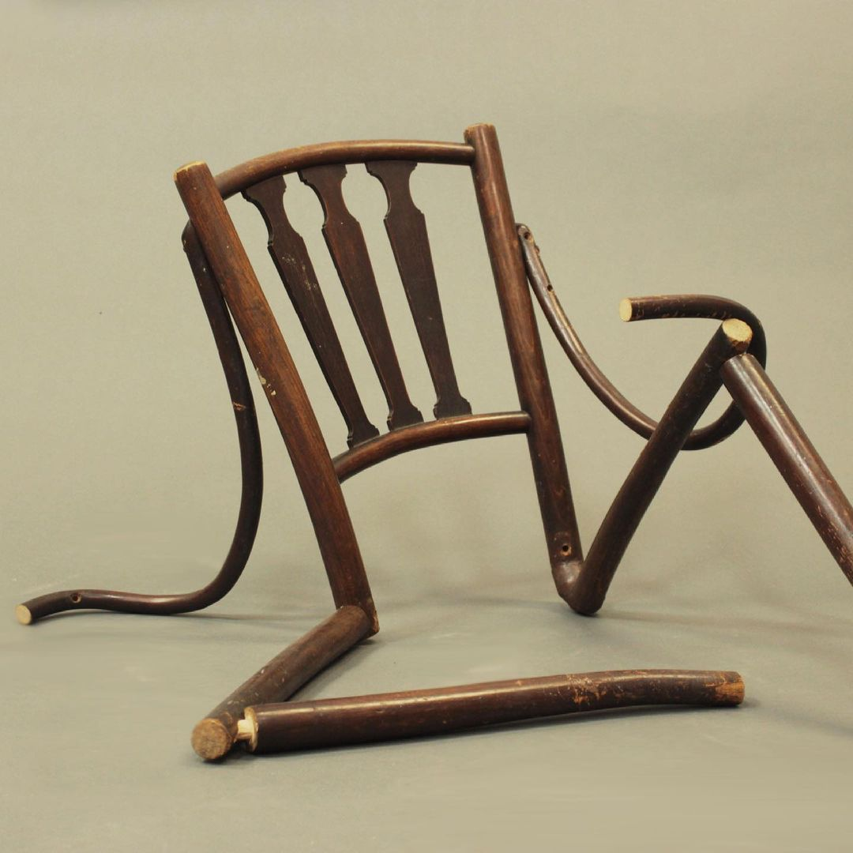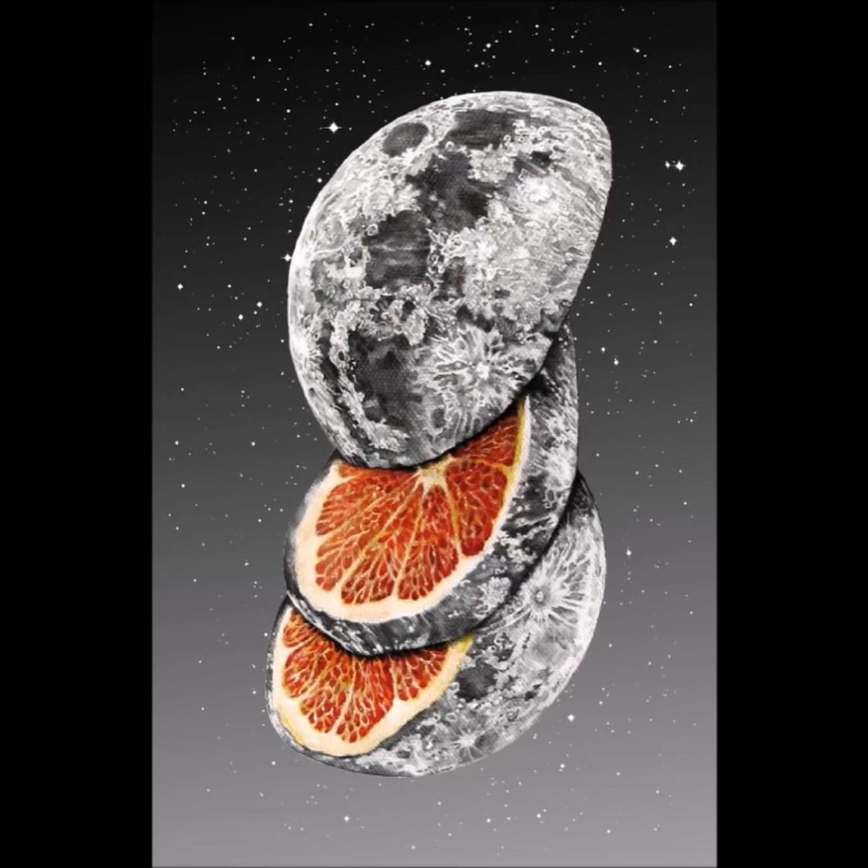

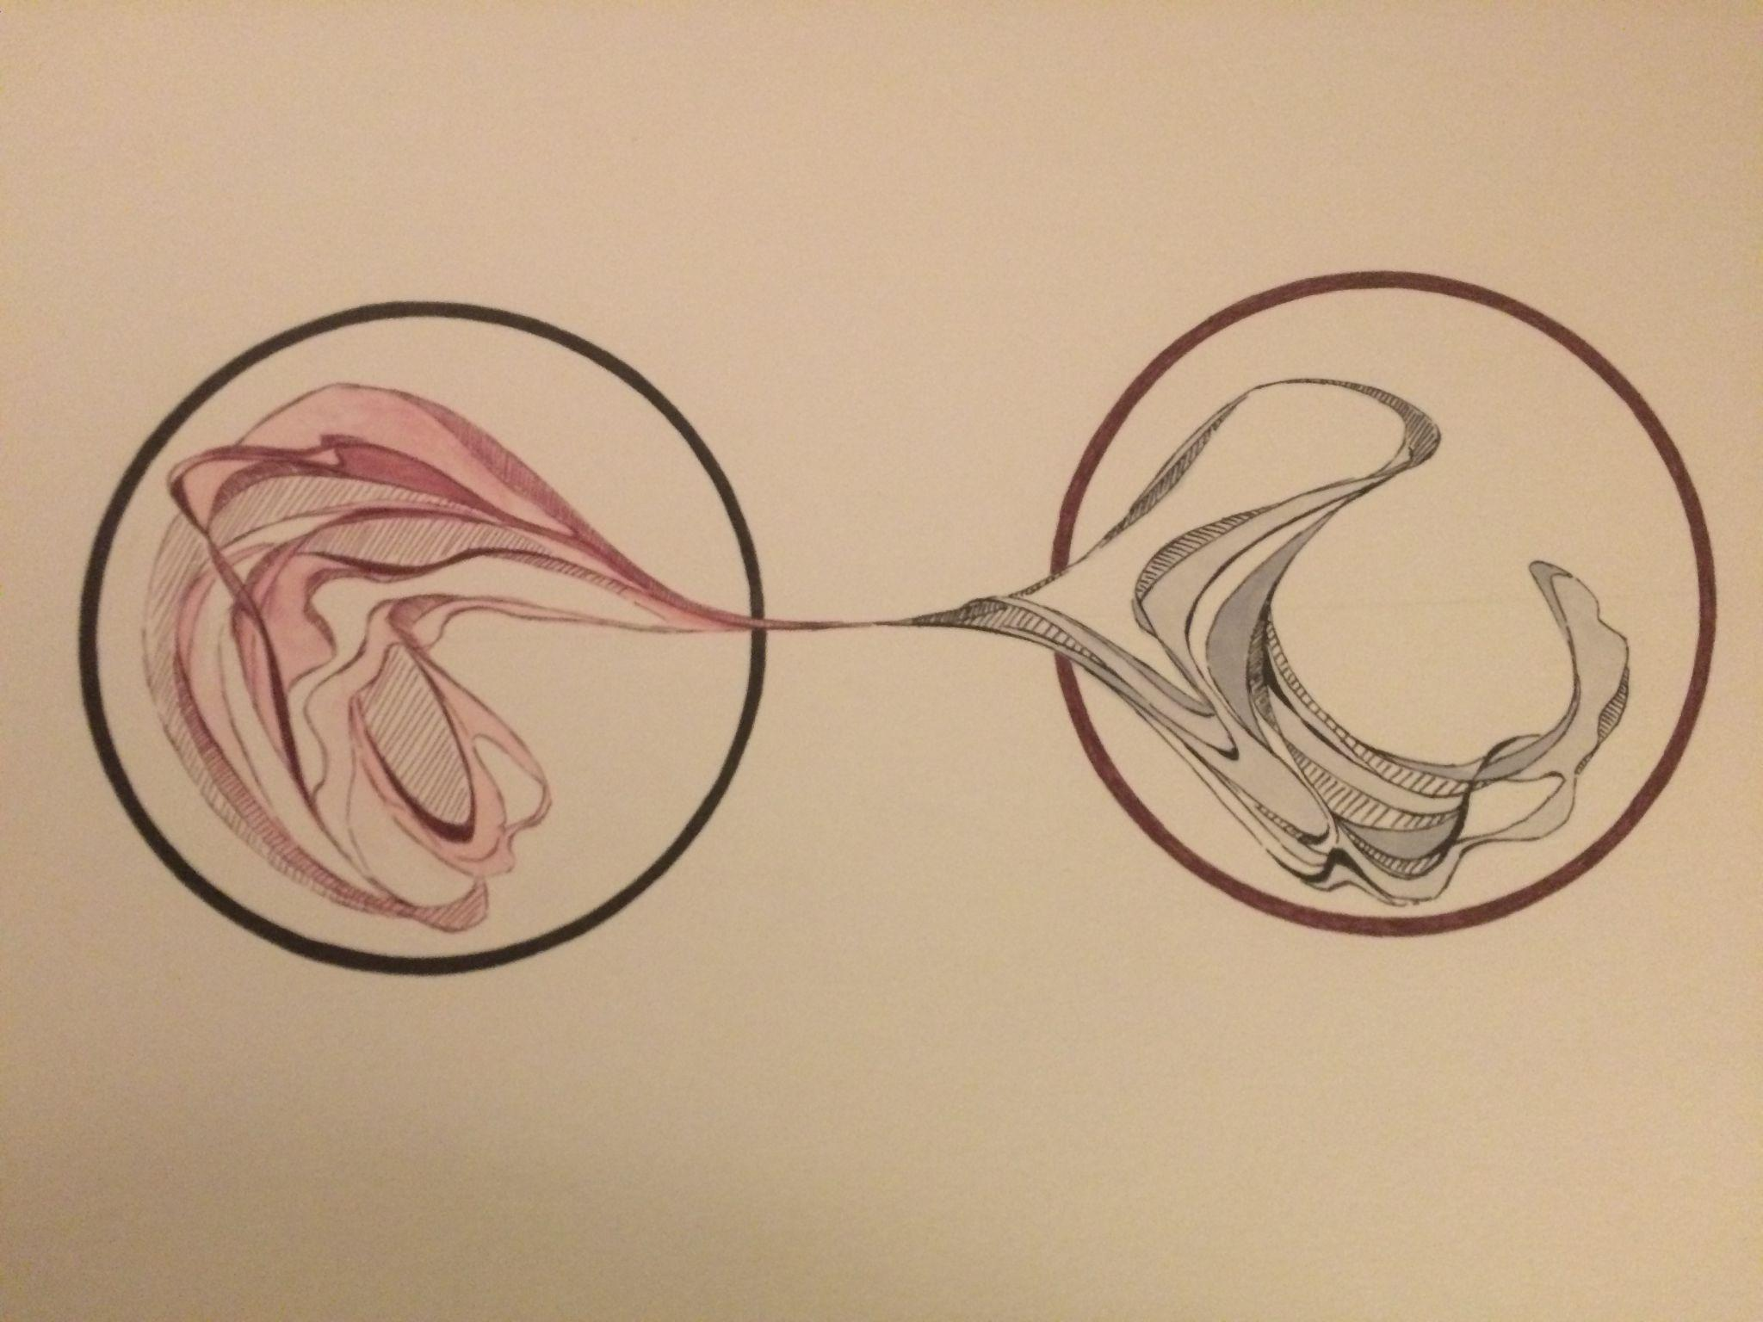



**'**

My feelings towards Art are very similar to what I've written above with Music. The difference, however is that I'm notably less-informed with art, lacking knowledge and language to describe my taste and draw accurate correlations.

That said, art is deeply fulfilling and full of life. There are people with certain tastes – alternative, modern, abstract, or technical and beautiful and standard mediums of watercolor or paint.

# **Personality Tests**

There's a million and one tests one can take and they're all fun.

Of course when one is testing themselves they're testing their conceptualization of themselves more than their presented-selves. Most of the tests posit some form of deeper core values, however I always have fluctuating results.  
  
For instance, my Myers Brigg test, I have notably completely changed my result from when I first took it and I'm happy about my change. My goal is to 50's across all the spectrums here. So far I'm reasonably successful at flipping my Extraversion/Introversion spectrum every time I take the test.

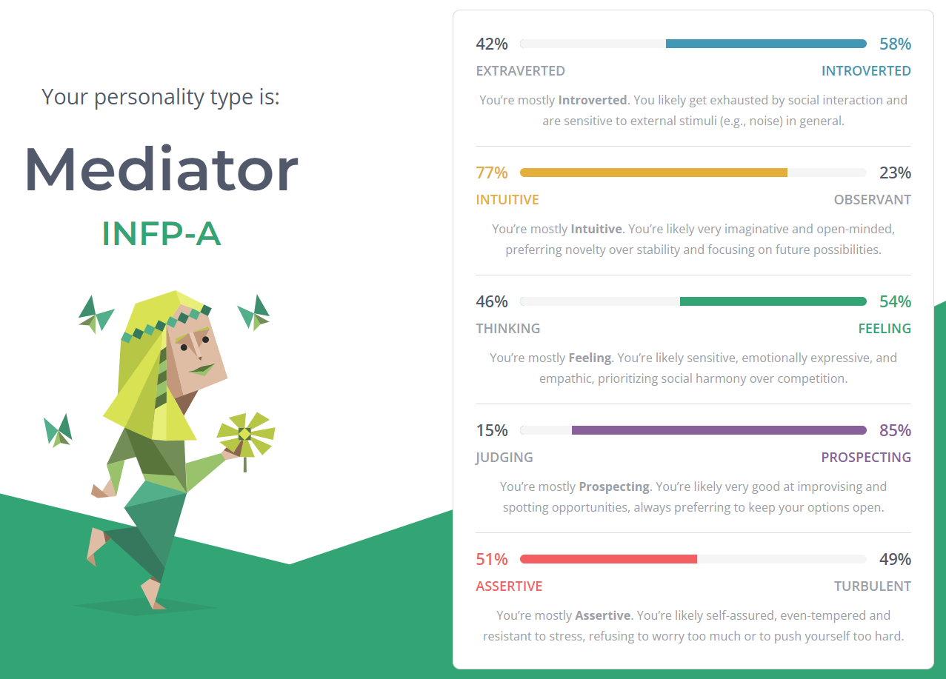

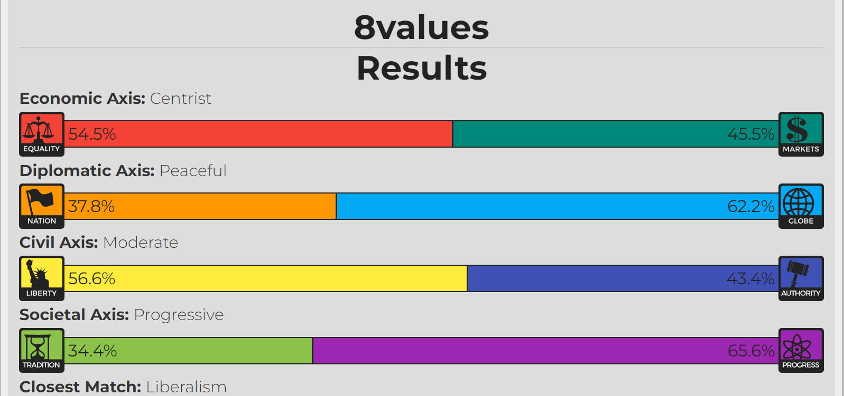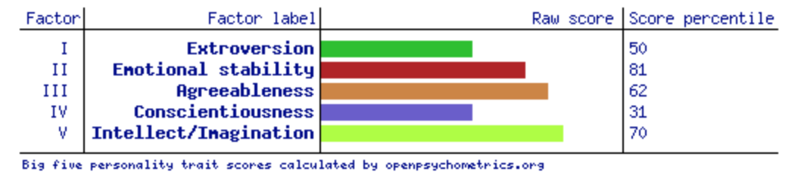

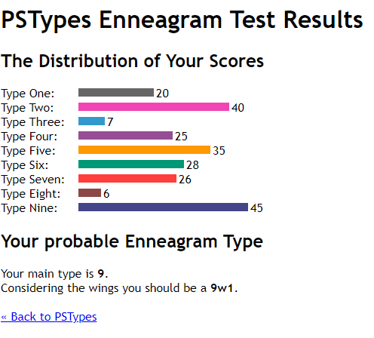

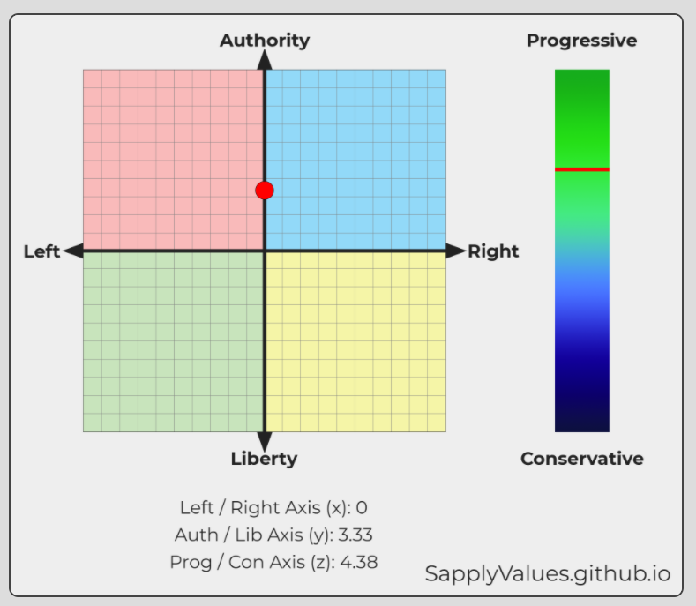

# **Astrology**

Gemini but something something presenting Aquarius.

Show me our compatibility and let's have fun.

# **Language**

See #language

# **Driving**

Shared space. Stress. Responsibility. Rules.

# **Hobbies**

If you're of a certain culture there's a strong correlation for the types of hobbies you have – boba, or alcohol, or coffee, or social dancing, or gambling, or animals, or guns, or cars, etc.

Life is full of fun patterns and the human within me meditates by piecing the jigsaw together.

"Everything must have a purpose?" asked God.

"Certainly," said man.

<https://www.youtube.com/watch?v=1Xfdjqa5dfY>

WILLOW - Wait a Minute!